When you talk about Data Visualization, the first word that comes to your mind is – Tableau. I am guessing that’s why you might be here reading this Tableau tutorial because you have heard about the advantages of Tableau.

**Importance Of Data Visualization**

Data Visualization is one of the most important part of data analysis. It has always been important to present the data in an understandable and visually appealing format. Data visualization is one of the skills that Data Scientists have to master in order to communicate better with the end users.

Data is the word here.

To put things in perspective, this data has largely been produced by websites and cross platform transactions. Add to it the fact that there would be a total of 20 billion “smart” devices connected to the internet by the end of 2020 and the numbers can be baffling!

Data visualization allows data scientists to converse with their end users. The outcome of data analysis is not immediately comprehensible to the people who do not directly deal with data. Data visualization bridges that gap and makes people appreciate the possibility of data analysis.

**Tableau Tutorial: Introduction To Data Visualization Tools**

Here are the top 5 data visualization tools that are being used extensively in BI:

1. Tableau
2. Qlikview
3. Domo
4. Microsoft power BI
5. Excel

**Why tableu:**

**Tableau connects to many different data sources and can visualize larger data sets than Power BI can. Once in Tableau, a dashboard shows the basics of the users’ data. The user can then drill down into data sets by downloading a worksheet. From there, they can apply various visualizations to the data.**

**Tableau can also process data in-memory by caching them in memory and not being connected to the source anymore while analyzing the data. Of course, there will be a limit to the amount of data cached depending on the availability of memory**

**There are three basic steps involved in creating any Tableau data analysis report.**

**These three steps are -**

**Connect to a data source - It involves locating the data and using an appropriate type of connection to read the data.**

**Choose dimensions and measures - This involves selecting the required columns from the source data for analysis.**

**Apply visualization technique - This involves applying required visualization methods, such as a specific chart or graph type to the data being analyzed.**

Data visualization is important to take smarter decisions.

Tableau can connect to any local file or database such as-

* Excel
* Text File
* Access
* Statistical File, or
* Other Database file.

Local connection gives the maximum speed of data processing.

Tableau can connect to your data server too. It can connect to almost any type of data server. Below are some of the most popular databases that Tableau can connect:

* Tableau Server
* Google Analytics
* Google BigQuery
* Hortonworks Hadoop Hive
* MapR Hadoop Hive
* IBM DB2
* IBM BigInsights
* IBM Netezza
* Microsoft SQL Server
* Microsoft Analysis Services
* Oracle
* Oracle Essbase
* MySQL
* PostgreSQL
* SAP

While working on Tableau, data can have Live Connection where any change in the source data will be automatically updated in Tableau. On the other hand, data can be Extracted to Tableau repository so that any change made here will not affect the

original source data.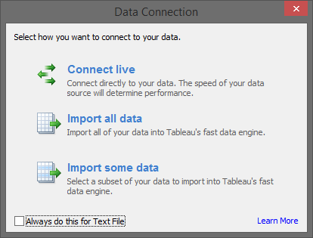

This is how the user interface looks like:

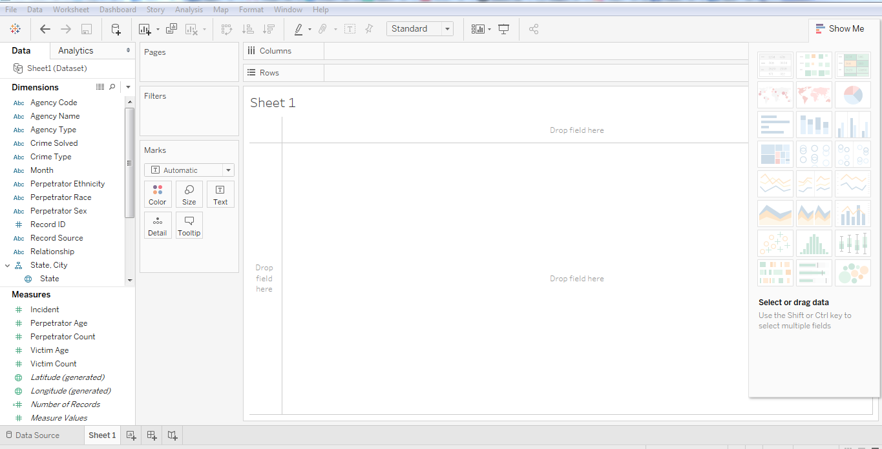

This is the pane with which you can create visualizations. You can create different visualization in order to represent your dataset.  The diagram below shows the ‘show me’ data pane:

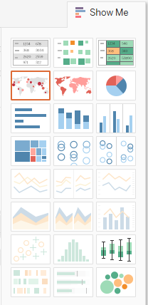

Some visualizations might not be available at times because of incompatible dataset.

You can create views manually by dragging and dropping the measures and dimensions in the view area.

To create views automatically select multiple fields by holding ctrl key and then click show me.

The following table tells you how to choose the right visualization for your dataset out of many available options.

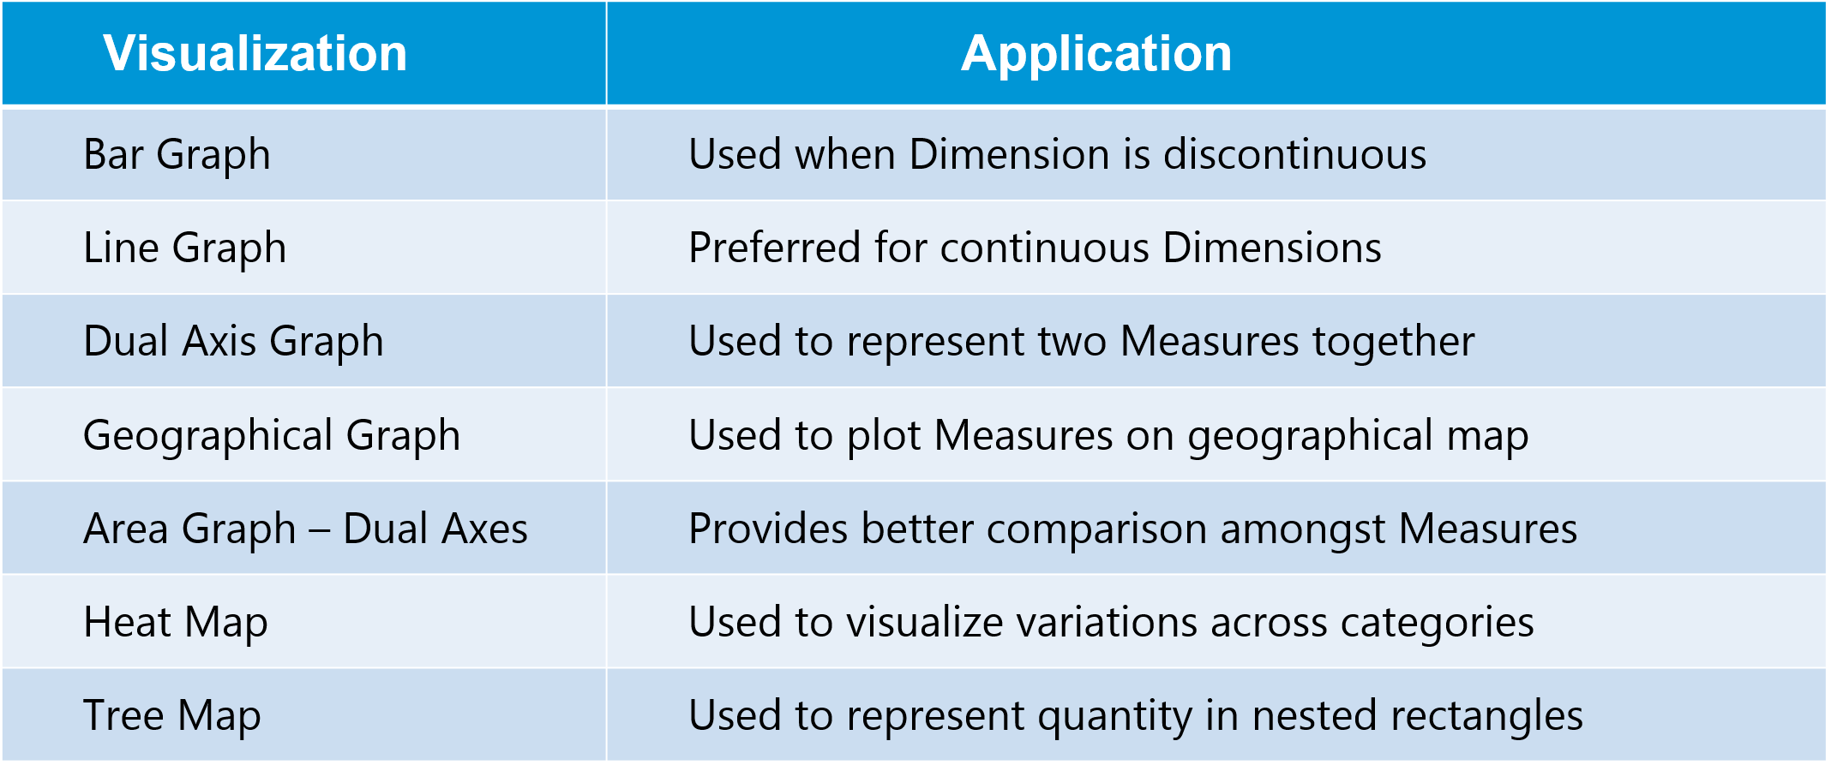

Different types of plotting available in Tableu

• [Text Table (Crosstab)](https://www.interworks.com/blogs/ccapitula/2014/08/04/tableau-essentials-chart-types-text-table)

• [Heat Map](https://www.interworks.com/blogs/ccapitula/2014/08/06/tableau-essentials-chart-types-heat-map)

• [Highlight Table](https://www.interworks.com/blogs/ccapitula/2014/08/06/tableau-essentials-chart-types-highlight-table)

• [Symbol Map](https://www.interworks.com/blogs/ccapitula/2014/08/18/tableau-essentials-chart-types-symbol-map)

• [Filled Map](https://www.interworks.com/blogs/ccapitula/2014/09/23/tableau-essentials-chart-types-filled-map)

• [Pie Chart](https://www.interworks.com/blogs/ccapitula/2014/09/26/tableau-essentials-chart-types-pie-chart)

• [Horizontal Bar Chart](https://www.interworks.com/blog/ccapitula/2014/09/30/tableau-essentials-chart-types-horizontal-bar-chart)

• [Stacked Bar Chart](https://www.interworks.com/blogs/ccapitula/2014/10/03/tableau-essentials-chart-types-stacked-bar-chart)

• [Side-by-Side Bar Chart](https://www.interworks.com/blogs/ccapitula/2014/10/08/tableau-essentials-chart-types-side-side-bar-chart)

• [Treemap](https://www.interworks.com/blogs/ccapitula/2014/10/14/tableau-essentials-chart-types-treemap)

• [Circle View](https://www.interworks.com/blogs/ccapitula/2014/10/17/tableau-essentials-chart-types-circle-view)

• [Side-by-Side Circle View](https://www.interworks.com/blogs/ccapitula/2014/10/22/tableau-essentials-chart-types-side-side-circle-view)

• [Line Charts (Continuous & Discrete)](https://www.interworks.com/blogs/ccapitula/2014/10/28/tableau-essentials-chart-types-line-charts-continuous-discrete)

• [Dual-Line Chart (Non-Synchronized)](https://www.interworks.com/blogs/ccapitula/2014/11/05/tableau-essentials-chart-types-dual-line-chart-non-synchronized)

• [Area Charts (Continuous & Discrete)](https://www.interworks.com/blogs/ccapitula/2014/11/13/tableau-essentials-chart-types-area-charts-continuous-discrete)

• [Scatter Plot](https://www.interworks.com/blogs/ccapitula/2014/11/21/tableau-essentials-chart-types-scatter-plot)

• [Histogram](https://www.interworks.com/blogs/ccapitula/2014/11/26/tableau-essentials-chart-types-histogram)

• [Box-and-Whisker Plot](https://www.interworks.com/blogs/ccapitula/2014/12/09/tableau-essentials-chart-types-box-and-whisker-plot)

• [Gantt Chart](https://www.interworks.com/blogs/ccapitula/2014/12/18/tableau-essentials-chart-types-gantt-chart)

• [Bullet Graph](https://www.interworks.com/blogs/ccapitula/2014/12/29/tableau-essentials-chart-types-bullet-graph)

• Packed Bubbles

There are some advanced visualization methods like below.

Waterfall Charts

Bump Charts

Funnel Charts

Box Plot

Pareto Charts

Histograms and Others

Combine Data Sources

Tableau can connect to different data sources at the same time. For example, in a single workbook you can connect to a flat file and a relational source by defining multiple connections. This is used in data blending, which is a very unique feature in Tableau.